Chapter 26
Working Capital Management
26-1. Answer the following questions:
a. What is the difference between a firm’s cash cycle and its operating cycle?
b. How will a firm’s cash cycle be affected if a firm increases its inventory, all else being equal?
c. How will a firm’s cash cycle be affected if a firm begins to take the discounts offered by its suppliers, all else being equal?
a. A firm’s cash cycle is the average length of time from when a firm pays cash for its inventory to when it receives cash from the sale of that inventory (or the end product that the firm produced with the inventory). It is calculated as the average number of days between the purchase of the initial inventory and the sale of the end product plus the average number of days it takes the firm’s customers to pay cash for the inventory they purchase minus the average number of days the firm takes to pay its suppliers for the inventory. A firm’s operating cycle is the average length of time between when a firm purchases its inventory and when the firm receives cash from the sale of the inventory. It is calculated as the average number of days between the purchase of the initial inventory and the sale of the end product plus the average number of days it takes the firm’s customers to pay for the inventory they purchase. If a firm were to pay cash for its inventory, rather than buying the inventory on credit, the cash cycle and the operating cycle of the firm would be identical. In most cases, however, firms buy their inventory on credit, so the cash cycle is shorter than the operating cycle of the firm.
b. If a firm increases its inventory, its inventory days will increase, all else being equal. This will, therefore, increase the cash cycle of the firm.
c. If a firm begins to take discounts offered by its suppliers, its accounts payable days will decrease. All else equal, this will cause the cash cycle of the firm to increase.
26-2. Does an increase in a firm’s cash cycle necessarily mean that a firm is managing its cash poorly?
No. An increase in a firm’s cash cycle does not necessarily mean that the firm is managing its cash poorly. The increase may be due to a conscious management decision. For example, a firm may decide to increase its inventory if it has been experiencing excessive stock-outs. All else being equal, this would result in an increase in its cash cycle. Or a firm may decide to loosen its credit policy in order to attract customers from its competitors. This would result in an increase in accounts receivable days, and all else being equal, result in an increase in the firm’s cash cycle. If a firm chooses to take the discounts offered by its suppliers, the accounts payable days will decrease, leading to an increase in the firm’s cash cycle.
26-3. Aberdeen Outboard Motors is contemplating building a new plant. The company anticipates that the plant will require an initial investment of $2 million in net working capital today. The plant will last 10 years, at which point the full investment in net working capital will be recovered. Given an annual discount rate of 6%, what is the net present value of this working capital investment?
Ignoring revenues and other expenses associated with the new plant, the NPV of the $2 million investment in net working capital is simply the present value of the $2 million that the firm will recoup at the end of ten years minus the initial $2 million investment.
NPV = –$2,000,000 + 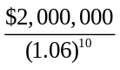 = –$883,210

26-4. The Greek Connection had sales of $32 million in 2009, and a cost of goods sold of $20 million. A simplified balance sheet for the firm appears below:
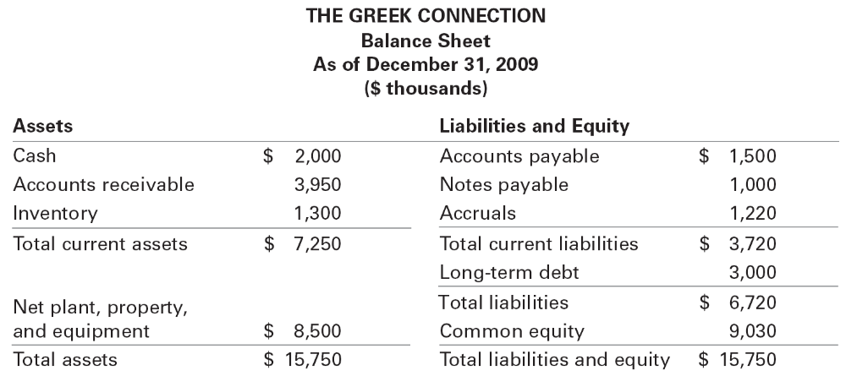
a. Calculate The Greek Connection’s net working capital in 2009.
b. Calculate the cash conversion cycle of The Greek Connection in 2009.
c. The industry average accounts receivable days is 30 days. What would the cash conversion cycle for The Greek Connection have been in 2009 had it matched the industry average for accounts receivable days?
a. Net working capital is current assets minus current liabilities. Using this definition, The Greek Connection’s net working capital is $7,250 – $3,720 = $3,530. Some analysts calculate the net operating working capital instead, which is the non-interest earning current assets minus the non-interest bearing current liabilities. In this case, the notes payable would not be included in the calculation since they are assumed to be interest bearing. Net operating working capital for The Greek Connection is $7,250 – ($1,500 + $1,220) = $4,530.
b. The cash conversion cycle (CCC) is equal to the inventory days plus the accounts receivable days minus the accounts payable days. The Greek Connection’s cash conversion cycle for 2004 was 41.4 days.
CCC = 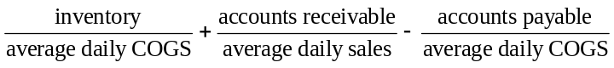
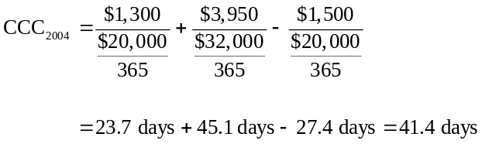
c. If The Greek Connection accounts receivable days had been 30 days, its cash conversion cycle would have been only 26.3 days:
CCC = 23.7 days + 30 days – 27.4 days = 26.3 days
26-5. Assume the credit terms offered to your firm by your suppliers are 3/5, Net 30. Calculate the cost of the trade credit if your firm does not take the discount and pays on day 30.
In this instance, the customer will have the use of $97 for an additional 25 days (30 – 5) if he chooses not to take the discount. It will cost him $3 to do so since he must pay $100 for the goods if he pays after the 5-day discount period. Thus, the interest rate per period is:
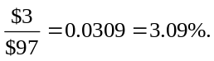
The number of 25-day periods in a year is 365/25 = 14.6 periods. So the effective annual cost of the trade credit is:
EAR = (1.0309)^{14.6} – 1 = 55.94%.
26-6. Your supplier offers terms of 1/10, Net 45. What is the effective annual cost of trade credit if you choose to forgo the discount and pay on day 45?
If you were to pay within the 10-day discount period, you would pay $99 for $100 worth of goods. If you wait until day 45, you will owe $100. Thus, you are paying $1 in interest for a 35-day (45 – 10) loan. The interest rate per period is:
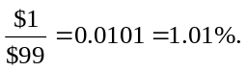
The number of 35-day periods in a year is 365/35 = 10.43 periods. So the effective annual cost of the trade credit is:
EAR = (1.0101)^{10.43} – 1 = 11.05%.
26-7. The Fast Reader Company supplies bulletin board services to numerous hotel chains nationwide. The owner of the firm is investigating the benefit of employing a billing firm to do her billing and collections. Because the billing firm specializes in these services, collection float will be reduced by 20 days. Average daily collections are $1200, and the owner can earn 8% annually (expressed as an APR with monthly compounding) on her investments. If the billing firm charges $250 per month, should the owner employ the billing firm?
The benefit of outsourcing the billing and collection to the other firm is equal to what Fast Reader can earn on the funds that are freed up. Since average daily collections are $1,200 and float will be reduced by 20 days, Fast Reader will have an additional $24,000 ($1,200 × 20). (Think about this as follows. Immediately after hiring the billing firm, its collection float drops by 20 days, so all collections due within the next 20 days are immediately available.) The billing firm charges $250 per month. At an 8% annual rate, the monthly discount rate is 1.081/12 – 1 = 6.43%, so the present value of these charges in perpetuity is 250/0.0643 = $38,856. Thus, the costs ($38,856) exceed the benefits ($24,000), and Fast Reader should not employ the billing firm.
26-8. The Saban Corporation is trying to decide whether to switch to a bank that will accommodate electronic funds transfers from Saban’s customers. Saban’s financial manager believes the new system would decrease its collection float by as much as five days. The new bank would require a compensating balance of $30,000, whereas its present bank has no compensating balance requirement. Saban’s average daily collections are $10,000, and it can earn 8% on its short-term investments. Should Saban make the switch? (Assume the compensating balance at the new bank will be deposited in a non-interest-earning account.)
The electronic funds transfer system will free up $50,000 (= 5 × $10,000) (Think about this as follows. Immediately after switching banks its collections due within the next five days are immediately available.) On the other hand, Saban will have to pay a cost because it has to hold $30,000 in a non-interest earning account, which means it has essentially given up these funds. Because the benefits ($50,000) are larger than the costs ($30,000) it should switch banks.
26-9. What are the three steps involved in establishing a credit policy?
The three steps involved in establishing a credit policy are:
(1) Establish credit standards. In this step, the firm must decide how much credit risk it is willing to accept.
(2) Establish credit terms. Here, the firm decides on the length of time before payment must be made and whether or not it will offer a discount. If a discount is to be offered, the amount of the discount and the length of the discount period must also be established.
(3) Establish a collection policy. In this step, the firm must decide how it will handle late payers.
26-10. The Manana Corporation had sales of $60 million this year. Its accounts receivable balance averaged $2 million. How long, on average, does it take the firm to collect on its sales?
If we assume all the sales were made on credit, the average length of time it takes Manana to collect on its sales is 12.2 days:
Accounts receivable days = 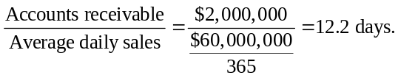
26-11. The Mighty Power Tool Company has the following accounts on its books:
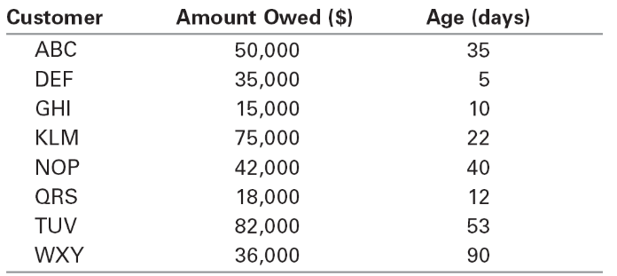
The firm extends credit on terms of 1/15, Net 30. Develop an aging schedule using 15-day increments through 60 days, and then indicate any accounts that have been outstanding for more than 60 days.
Mighty Power Tool Company Aging Schedule
Percent of
Days Outstanding Amount Owed Accounts Receivable
0–15 $ 68,000 19.3%
16–30 $ 75,000 21.2%
31–45 $ 92,000 26.1%
46–60 $ 82,000 23.2%
over 60 $ 36,000 10.2%
$353,000 100.0%
26-12. What is meant by “stretching the accounts payable”?
“Stretching the accounts payable” refers to a customer’s not paying by the payment date specified.
26-13. Simple Simon’s Bakery purchases supplies on terms of 1/10, Net 25. If Simple Simon’s chooses to take the discount offered, it must obtain a bank loan to meet its short-term financing needs. A local bank has quoted Simple Simon’s owner an interest rate of 12% on borrowed funds. Should Simple Simon’s enter the loan agreement with the bank and begin taking the discount?
If Simple Simon’s takes the discount, it must pay $99 in 10 days for every $100 of purchases. If it elects not to take the discount, it will owe the full $100 in 25 days. The interest rate on the loan is:
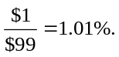
The loan period is 15 days (= 25 – 10). The effective annual cost of the trade credit is:
EAR = (1.0101)^{365/15} – 1 = 27.7%.
Since the bank loan is only 12%, Simple Simon should borrow the funds from the bank in order to take advantage of the discount.
26-14. Your firm purchases goods from its supplier on terms of 3/15, Net 40.
a. What is the effective annual cost to your firm if it chooses not to take the discount and makes its payment on day 40?
b. What is the effective annual cost to your firm if it chooses not to take the discount and makes its payment on day 50?
a. Your firm is paying $3 to borrow $97 for 25 days (= 40 – 15). The interest rate per period is:
The effective annual rate is (1.0309)^{365/25} – 1 = 55.9%.
b. In this case, your firm is stretching its accounts payable. You are still paying $3 to borrow $97, so the interest rate per period is 3.09%. However, the loan period is now 35 days (= 50 – 15). The effective annual rate is reduced to 37.4% because your firm has use of the money for a longer period of time:
EAR = (1.0309)^{365/35} – 1 = 37.4%.
26-15. Use the financial statements supplied below for International Motor Corporation (IMC) to answer the following questions.
a. Calculate the cash conversion cycle for IMC for both 2009 and 2010. What change has occurred, if any? All else being equal, how does this change affect IMC’s need for cash?
b. IMC’s suppliers offer terms of Net 30. Does it appear that IMC is doing a good job of managing its accounts payable?
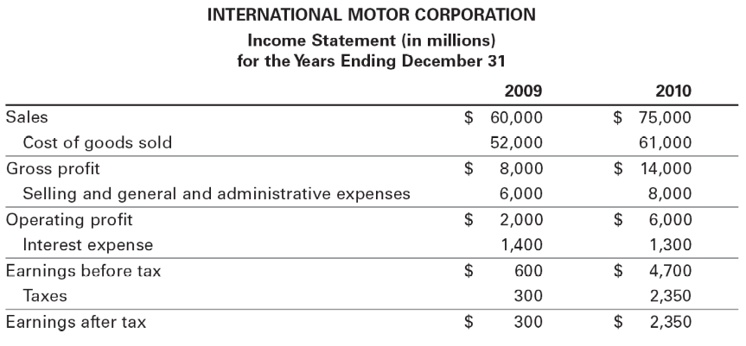
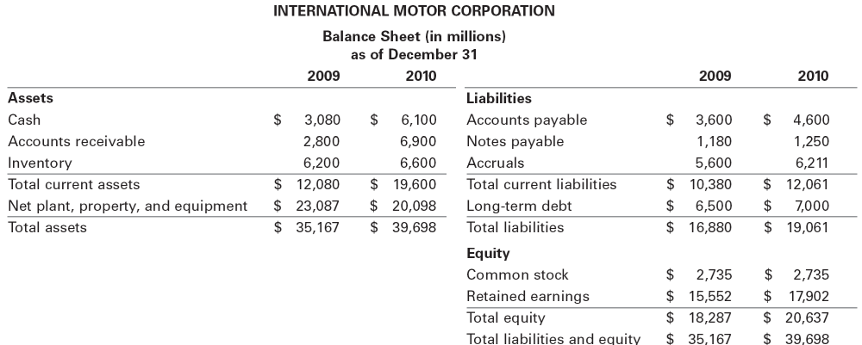

a. The cash conversion cycle (CCC) is equal to the inventory days plus the accounts receivable days minus the accounts payable days. IMC’s cash conversion cycle for 2003 was 35.2 days, and for 2004, it was 45.6 days.
CCC =
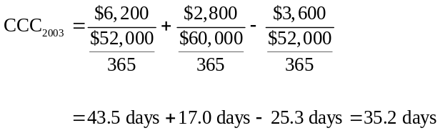
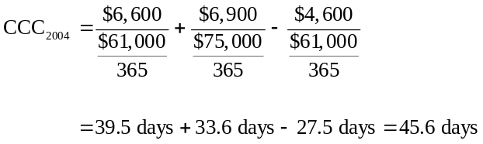
IMC’s cash conversion cycle has lengthened in 2004, due to an increase in its accounts receivable days. The number of days goods are held in inventory has decreased, and IMC is taking longer to pay its suppliers, both of which would decrease the cash conversion cycle, all else being equal. These changes were not enough to offset the increase in the amount of time it is taking IMC’s customers to pay for purchases made on credit. The lengthening of the cash conversion cycle means that IMC will require more cash.
b. If IMC’s suppliers are offering terms of net 30, IMC should consider waiting longer to pay for its purchases. In 2003, it paid nearly five days earlier than necessary, and in 2004, it paid 2.5 days earlier. IMC could, therefore, have kept the money working for it longer because there was no discount offered for early payment. The early payment may give IMC a preferred position with its suppliers, however, which may have benefits that are not presented here. IMC’s decision on whether to extend its accounts payable days would have to take these benefits into consideration.
26-16. Ohio Valley Homecare Suppliers, Inc. (OVHS), had $20 million in sales in 2009. Its cost of goods sold was $8 million, and its average inventory balance was $2,000,000.
a. Calculate the average number of inventory days outstanding for OVHS.
b. The average days of inventory in the industry is 73 days. By how much would OVHS reduce its investment in inventory if it could improve its inventory days to meet the industry average?
a. The inventory days ratio is equal to the inventory divided by average daily cost of goods sold. This was 91.25 days for Ohio Valley Homecare Suppliers in 2004:
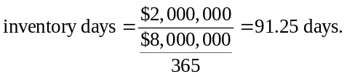
The inventory turnover ratio for Ohio Valley Homecare Supplies was four times in 2004:
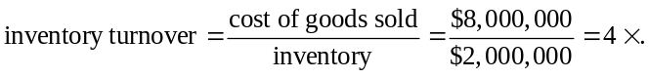
b. OVHS could increase its inventory turnover to five times by reducing its inventory to $1,600,000:
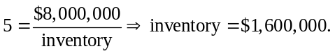
This means OVHS could reduce its investment in inventory by $400,000 (= $2,000,000 – $1,600,000).
26-17. Which of the following short-term securities would you expect to offer the highest before-tax return: Treasury bills, certificates of deposit, short-term tax exempts, or commercial paper? Why?
Commercial paper. Treasury bills and certificates of deposit are considered to be free of default risk, so they offer lower returns than a security that has default risk associated with it. Short-term tax exempts have default risk, but the interest on these instruments is free from federal taxation; thus, they offer a lower yield than a similarly risky, fully taxable security. Commercial paper exposes the investor to default risk and the interest earned is fully taxable. It would, therefore, have to offer the investor a higher before-tax return than the other instruments.

